Aim: To design a One digit BCD adder.

Circuit diagram:

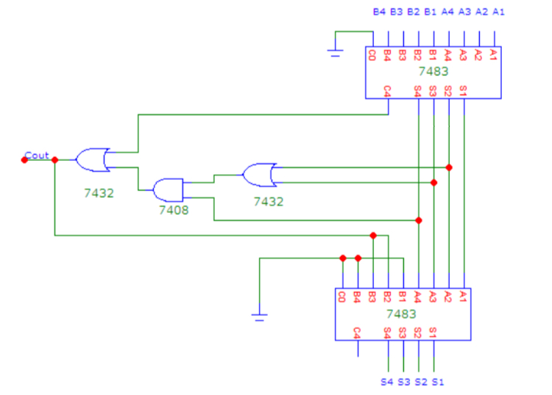

Output:

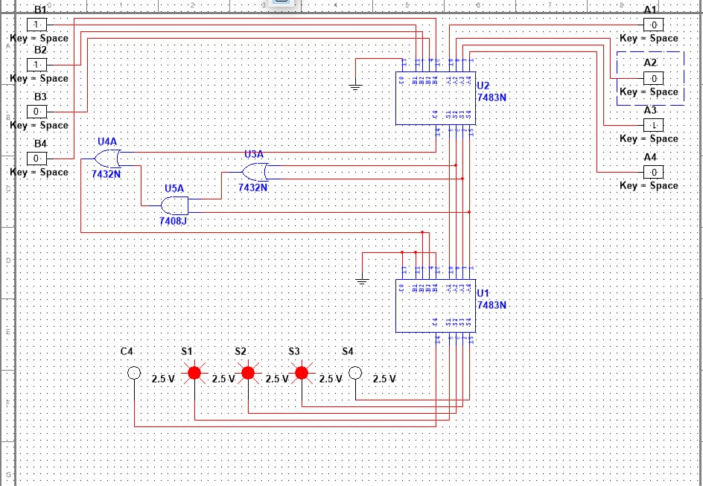

Aim: Excess-3 to BCD code conversion.

Circuit diagram:

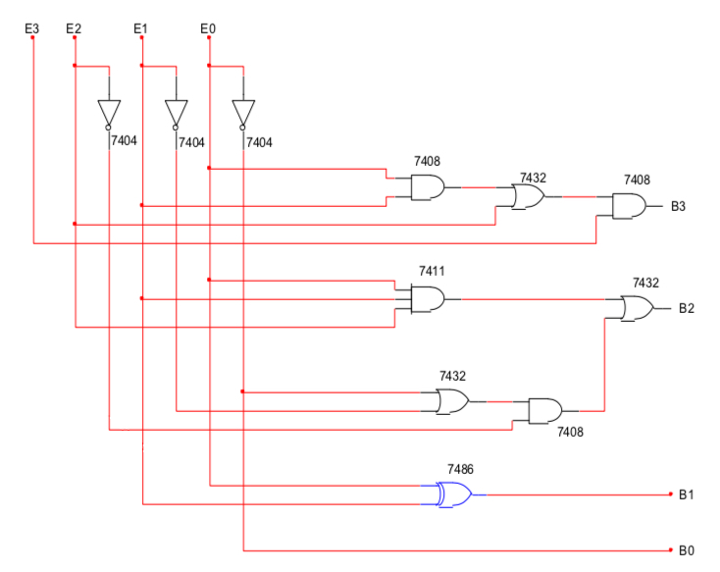

Output:

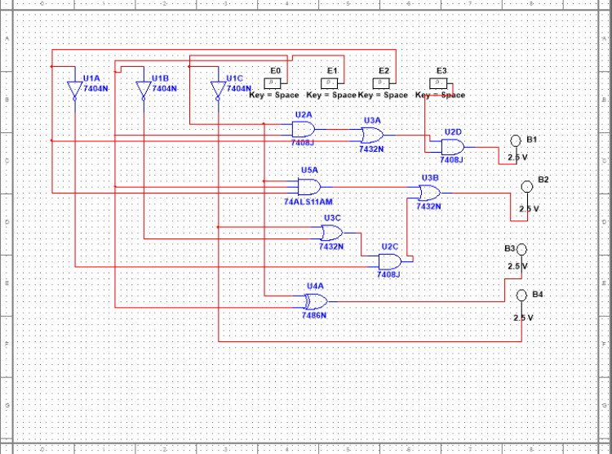

Aim: Gray to Binary code conversion.

Circuit diagram:

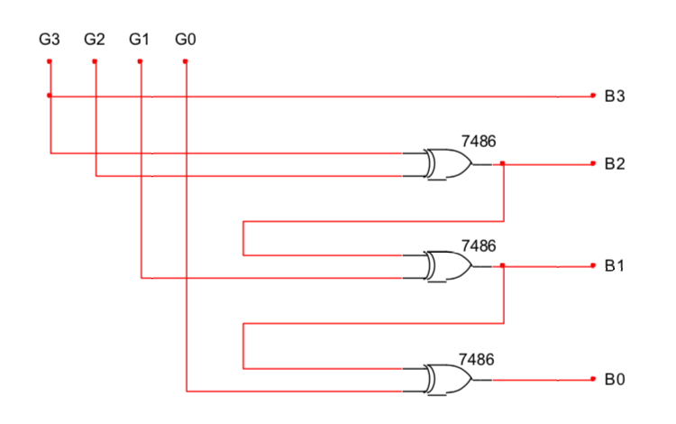

Output:

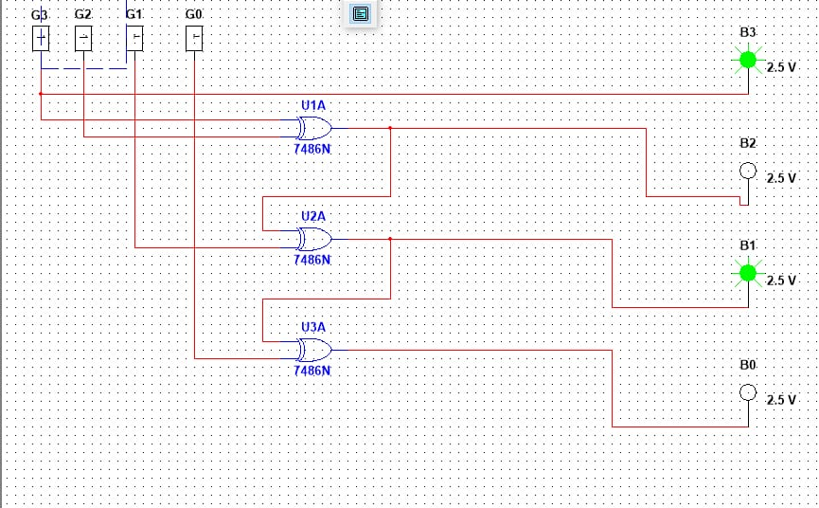

Aim: To design a One bit comparator.

Circuit diagram:

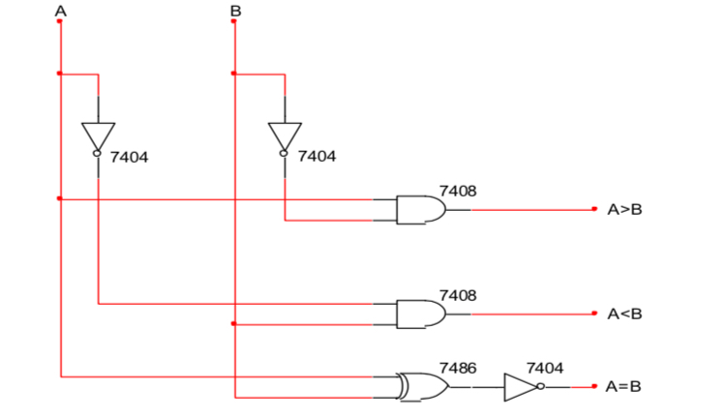

Output:

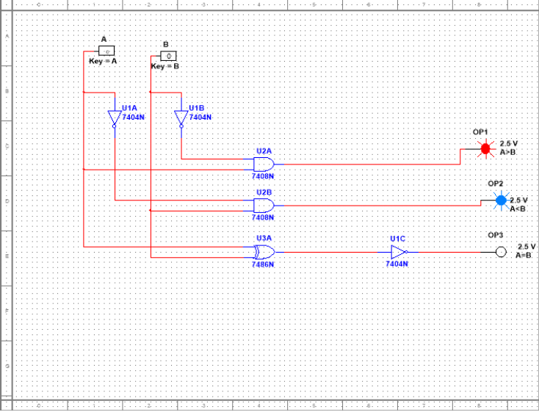

Aim: To design 8 bit comparator using IC7485.

Circuit diagram:

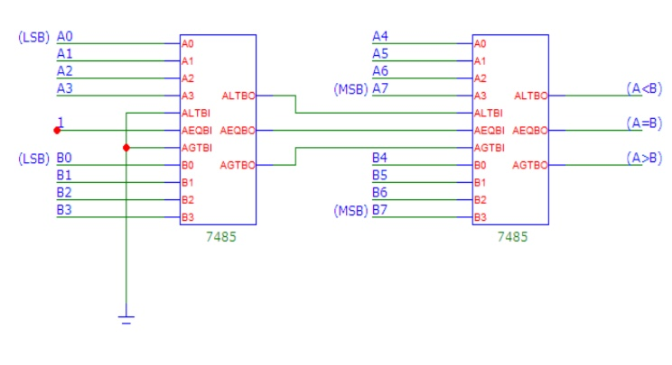

Output:

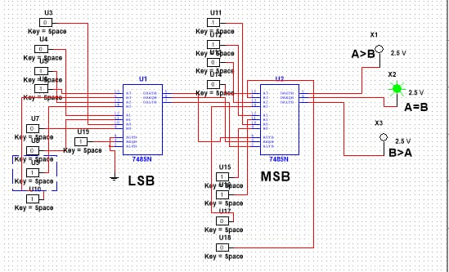

Aim: To design a Octal to binary encoder.

Circuit diagram:

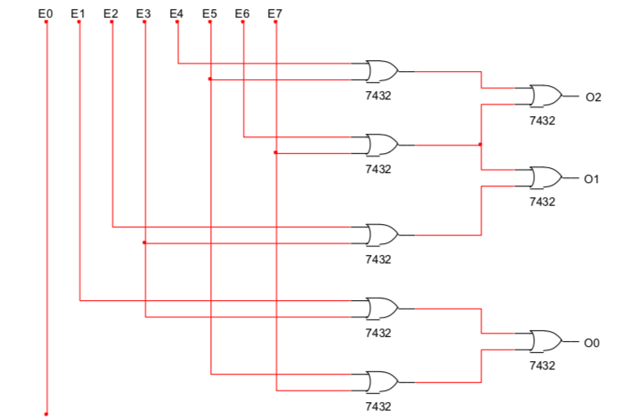

Output:

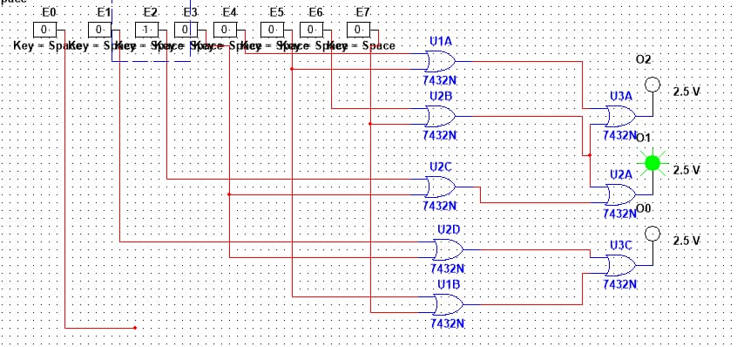

Aim: To design a 4:1 Multiplexer using logic gates.

Circuit diagram:

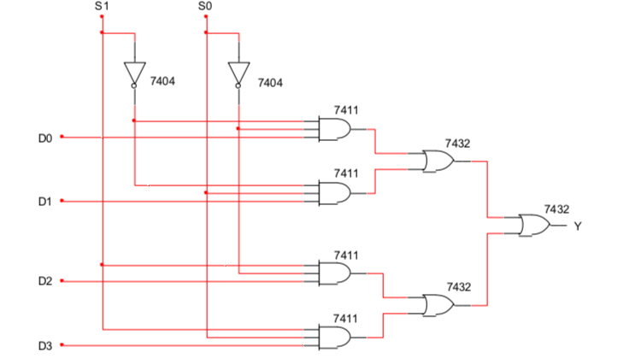

Output:

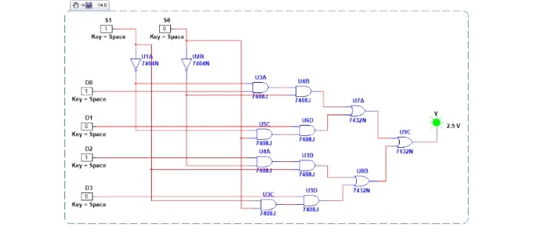

Aim: To Design 1:4 Demultiplexer using logic gates.

Circuit diagram:

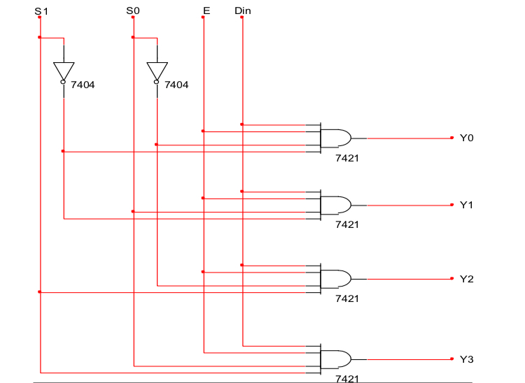

Output:

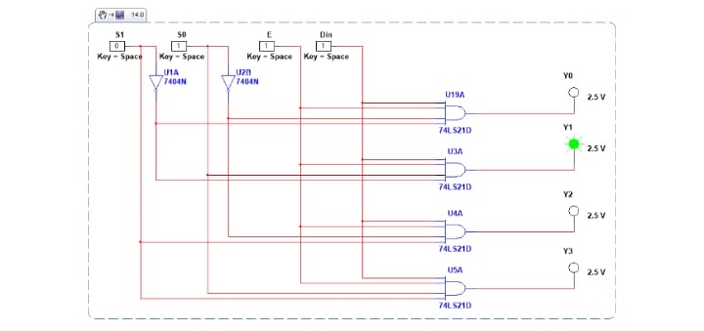

Aim: Code conversion using IC74139.

Circuit diagram:

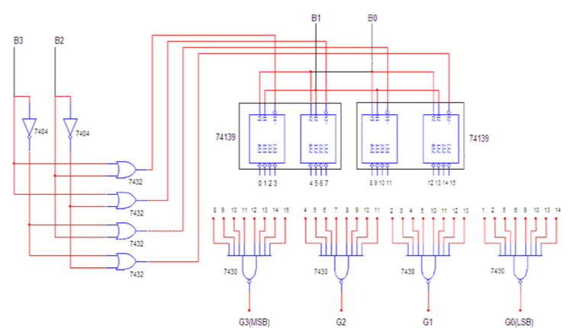

Output:

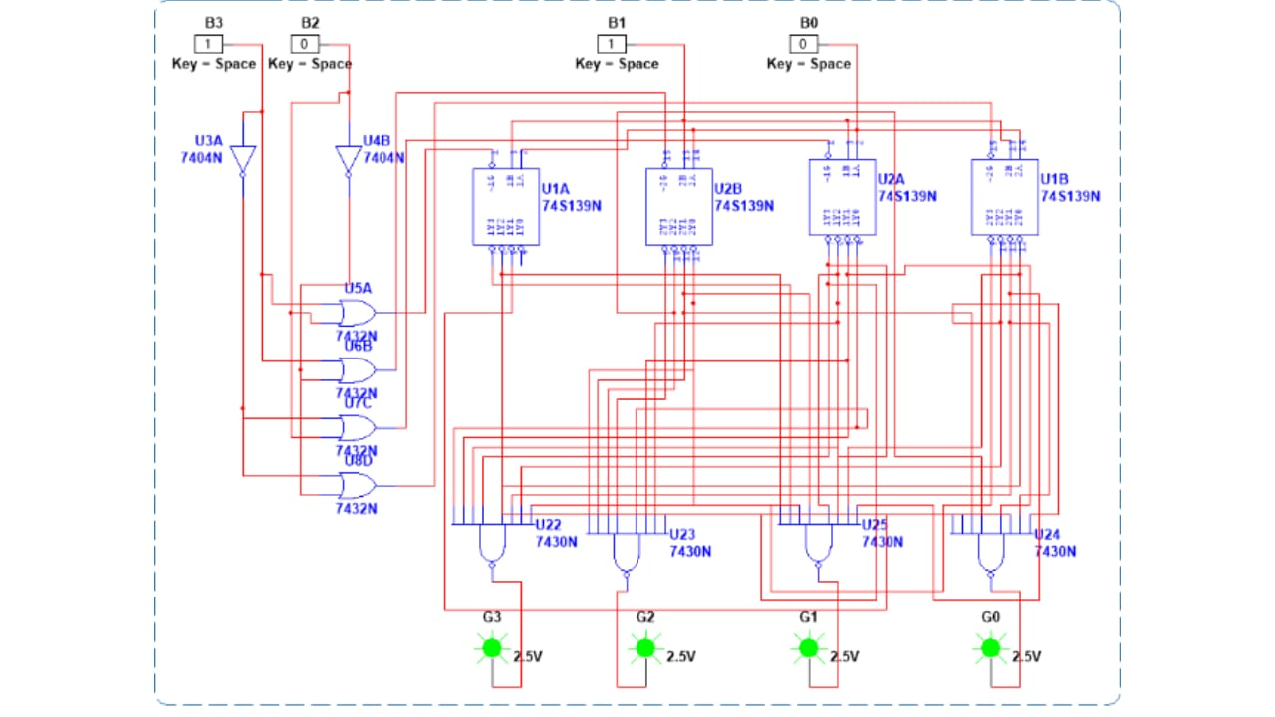

Aim :Design a D flipflop using logic gates

Circuit Diagram :

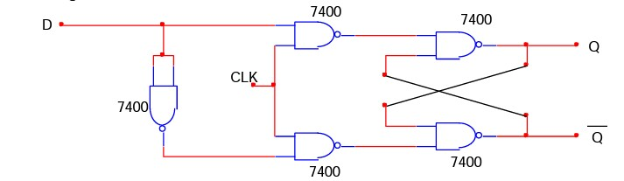

Output :

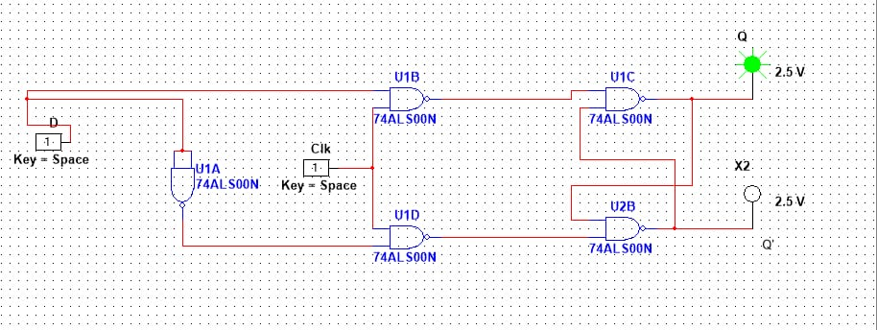

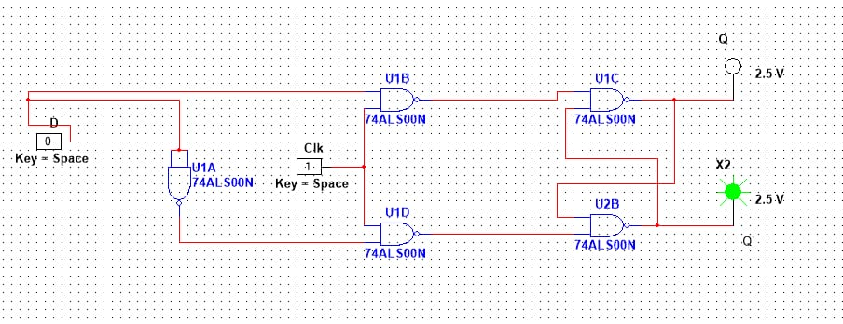

Aim : Design a T Flipflop using logic gates

Circuit Diagram :

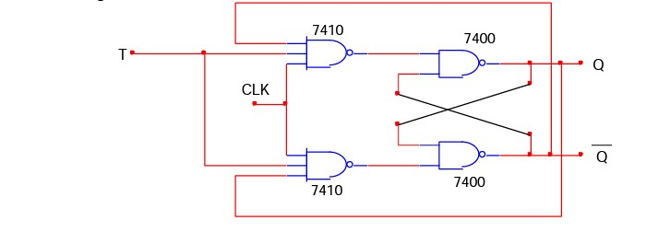

Output :

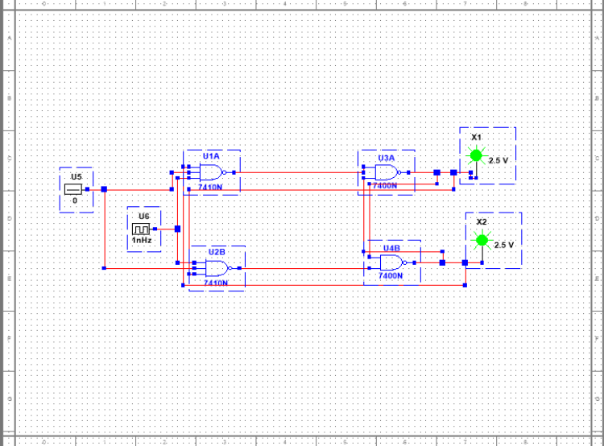

Aim :Design a Ring counter using JK Flipflop

Logic Diagram :

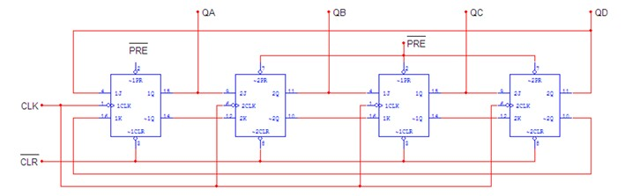

Output :

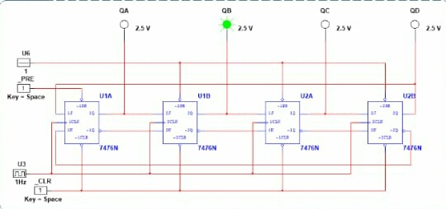

Aim :Design a Johnson counter using JK Flipflop

Circuit Diagram :

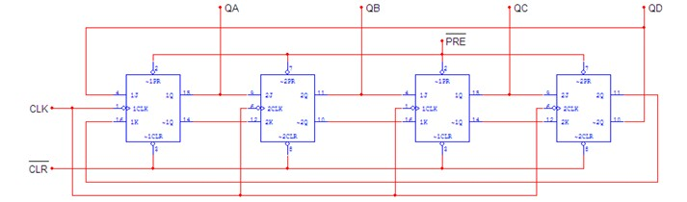

Output :

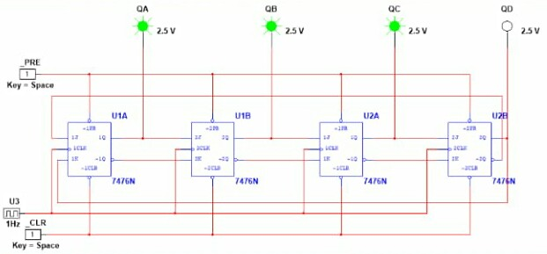

Aim :Design a MOD – 10 Down counter : Using 74192

Logic Diagram :

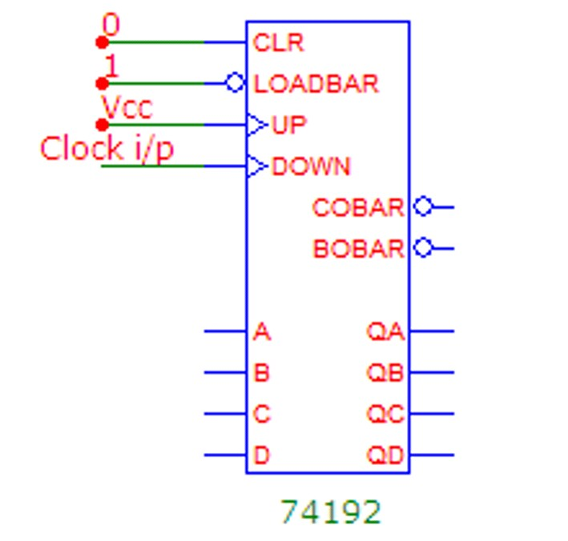

Output :

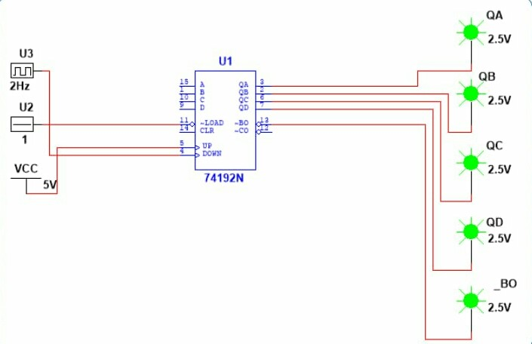

Aim :Design a MOD – 100 Counter : Counts from 99 to 0 using IC74192

Logic Diagram :

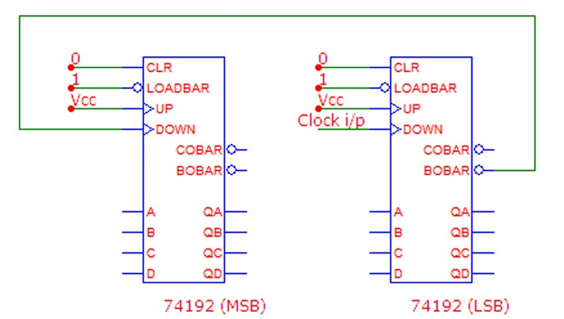

Output :

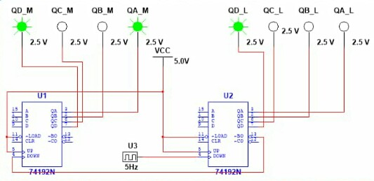

Aim :Generate the sequence 100010011010111 : length 15.

Logic Diagram :

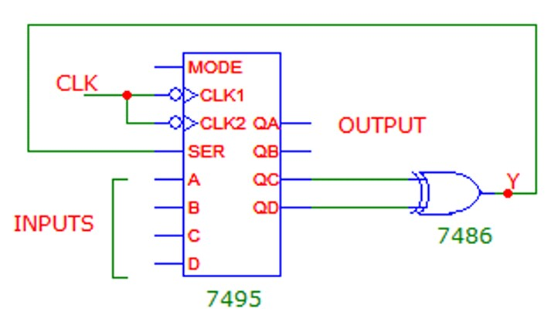

Output :

Aim :Generate the sequence 1001011: length 7.

Logic Diagam :

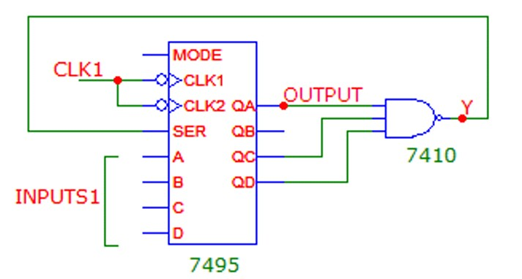

Output: